**2025 CLARE VALLEY FESTIVAL OF THE LAMB**

**INFORMATION SHEET and EOI FORM VENUES**

Background:

The Mintaro Progress Association (MPA) is staging the 6th Clare Valley Festival of the Lamb 17-21 September 2025 which is now an annual spring equinox festival combining the first buds of the vines and the premier time for new-season lamb that is lean, tender and ideal for a wide range of recipes.

A focus is on lamb and to be as ethical as possible in its preparation by having the restaurant / venue take a full lamb/s from the farmer which the chef will then utilising in consultation with a butcher and the farmer.

Visiting Chefs have been a feature in previous years including from Iceland, USA, China, North Queensland, Polish and Türkiye born chefs and last year Italian. For 2025 we will have a visiting Chef from Cambodia.

The MPA manages several events during the festival, and we assist with the coordination between venue’s restaurants / wineries / hotels and the farmer. Each venue is required to match their meal/s with local wines or beers and are encouraged to arrange entertainment / guest speakers and to feature the farmer and or industry rep with their event.

The concept is to have as many venues as possible holding 1 or more events during the festival and that these events allow the chef, farmer, wine maker / brewery to engage with the diners.

To be part of the 2025 Clare Valley Festival of the Lamb an application using the expression of interest form will need to be approved. Note the MPA continues to not charge venues to be part of the festival.

Whilst there will be an overall festival program developed and the MPA provides general marketing and a food writer/blogger, each venue is required to actively market their own event. We will be applying for grant funding from SATC and Clare & Gilbert Valleys Council to assist with marketing.

Following the success of the TAFE SA Wool Fashion Design Award in 2024 these will be expanded on in 2025 as will Art Exhibitions plus workshops and plans are underway for a forum titled “Celebrating Women in the Sheep Industry” these are all being designed for the Wednesday to Friday. The popular Wool and Fibre Markets will again be held on Sunday.

There are also plans for an Adelaide Launch in June that will feature Clare Valley Lamb and Wines at a venue in Adelaide. For further information contact Simon Millcock [simon_millcock@dodo.com.au](mailto:simon_millcock@dodo.com.au) phone 040781900

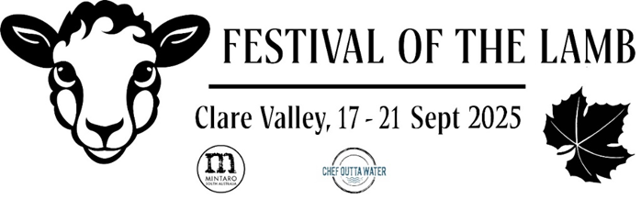

Expression of Interest – Venue

2025 Clare Valley Festival of the Lamb 17 - 21 September

*Note this is not to be taken as an approval and the MPA will respond to this EOI*

This form is to be returned by Friday 28 February 2025 to [simon_millcock@dodo.com.au](mailto:simon_millcock@dodo.com.au)

|  |  |
| --- | --- |
| Name of venue |  |
| Contact person |  |
| Contact phone |  |
| Contact email |  |
| Event name |  |
| Type of event |  |
| Proposed date |  |
| Do you need a link to a local lamb producer?  If not name, the producer you will work with. |  |
| Name of local winery / brewery that will be matched with the event. |  |
| Will you be having entertainment / speaker / guest chef, if yes provide details. |  |
| Other comments |  |